Brain Stroke Patient Data Analysis Report
Data cleaning, exploratory analysis, interactive dashboard, and logistic regression modeling
Prepared as a living report for ongoing analysis updates
Note: This report summarizes the work completed so far. The held-out testing dataset has not been evaluated for model performance.

1. Executive Summary
The brain stroke dataset was cleaned and prepared for analysis, explored through descriptive statistics and visualizations, converted into an interactive Tableau-style dashboard, and used to train logistic regression models for stroke prediction using the training dataset only.
Item | Result
Original cleaned dataset size | 4,981 rows x 20 columns
Overall stroke cases | 248 of 4,981 patients (5.0%)
Training dataset size | 2,490 rows x 11 columns
Training stroke distribution | 124 stroke / 2,366 no stroke
Selected model | Tuned balanced logistic regression, C = 0.1
Primary selection rationale | Highest PR-AUC among compared models with the best recall/sensitivity tied at 81.45%
Final model artifact | logistic_regression_stroke_model.pkl

2. Prompts Entered to Conduct Each Step

Step 1: Data cleaning, processing, EDA, and visualizations
you're a data analyst analyzing the pasted brain stroke patient data. make sure the data is clean and processed to be appropriate for use. then, explore the dataset and generate data visualizations in tableau, python, or any other suitable platform.

Step 2: Interactive Tableau-style dashboard
create an interactive dashboard (tableau style) with the visualizations

Step 3: Logistic regression stroke prediction modeling
You are a medical data analyst using AI and machine learning to build a stroke prediction model.
I have already split my original brain stroke patient dataset into training and testing datasets using stratified sampling. The training file is named:
train_dataset.csv
The target variable is:
stroke
where:
0 = No Stroke
1 = Stroke
Your task is to create a logistic regression model using only the training dataset. Do not use the testing dataset yet.
Please complete the following steps:
Load train_dataset.csv into Python using Pandas.
Confirm the dataset size and display the distribution of the stroke target variable.
Separate the dataset into:
Features: X
Target variable: y = stroke
If an ID column exists, such as id, remove it from the model because it is not clinically predictive.
Identify numerical and categorical variables.
Build a preprocessing pipeline that:
Imputes missing numerical values using the median
Imputes missing categorical values using the most frequent value
Scales numerical variables using StandardScaler
One-hot encodes categorical variables using OneHotEncoder(handle_unknown="ignore")
Build logistic regression models using scikit-learn pipelines.
Train and compare at least the following logistic regression models:
Model 1: Baseline Logistic Regression
Standard logistic regression
No class weighting
Model 2: Balanced Logistic Regression
Logistic regression using class_weight="balanced" to account for the low stroke rate
Model 3: Tuned Logistic Regression
Use cross-validation to tune the regularization strength C
Try several values such as 0.01, 0.1, 1, 10, and 100
Use stratified cross-validation so each fold keeps a similar stroke rate
Because stroke cases are rare, do not rely only on accuracy. Evaluate the models using:
Accuracy
Precision
Recall / Sensitivity
Specificity
F1-score
ROC-AUC
PR-AUC / Average Precision
Confusion matrix
Use stratified 5-fold cross-validation on the training dataset.
Report the results for each model in a clear comparison table.
Identify which logistic regression model performs best for stroke prediction and explain why.
Pay special attention to recall/sensitivity because missing a potential stroke case may be clinically serious.
After selecting the best logistic regression model, fit it on the full training dataset.
Save the final trained pipeline as:
logistic_regression_stroke_model.pkl
Also provide the model coefficients or odds ratios, if possible, and explain which variables appear to increase or decrease predicted stroke risk.
Provide clean, well-commented Python code using:
pandas
numpy
scikit-learn
joblib
Important restrictions:
Do not use test_dataset.csv yet.
Do not evaluate the final model on the testing dataset yet.
Do not perform advanced feature engineering unless it is necessary for logistic regression.
Keep the work focused on building, comparing, and saving logistic regression models using the training dataset only.
At the end, summarize:
Which logistic regression model was selected
Why it was selected
The most important performance metrics
Any concerns about class imbalance or clinical usefulness

Step 4: Current report generation
put the results so far into a report document. include the prompts that were entered to conduct each step in the analysis. you will update this document as more results are produced.

3. Data Cleaning and Processing Results
The uploaded source workbook was loaded and inspected. The data contained one worksheet with 4,981 records and 11 original columns. No missing values or duplicate rows were found. The cleaned analysis dataset contains standardized field names, normalized categorical labels, and additional analysis-ready fields.
Check | Result
Original rows | 4,981
Original columns | 11
Cleaned rows | 4,981
Cleaned columns | 20
Missing values identified | 0
Duplicate rows identified | 0
Invalid binary values in stroke, hypertension, or heart_disease | 0
Broadly implausible age, BMI, or glucose values | 0
Added fields included age_group, bmi_category, glucose_category, stroke_label, hypertension_label, heart_disease_label, and quality-control flags for age, BMI, and glucose.

4. Exploratory Data Analysis Findings
The full cleaned dataset had a low stroke prevalence of approximately 5.0%, meaning class imbalance is an important consideration for modeling.
Metric | Value
Stroke cases | 248
No-stroke cases | 4733
Overall stroke rate | 5.0%
Average age among stroke patients | 67.8
Average age among no-stroke patients | 42.1
Average glucose among stroke patients | 132.2
Average glucose among no-stroke patients | 104.6
Average BMI among stroke patients | 30.2
Average BMI among no-stroke patients | 28.4

Stroke rate by major risk grouping
Age group | Patients | Stroke_cases | Stroke_rate
Adult (36-50) | 1047 | 19 | 1.8%
Child (0-12) | 574 | 1 | 0.2%
Older adult (51-65) | 1134 | 70 | 6.2%
Senior (66+) | 959 | 156 | 16.3%
Teen (13-18) | 306 | 1 | 0.3%
Young adult (19-35) | 961 | 1 | 0.1%
Risk factor | Patients | Stroke_cases | Stroke_rate
Hypertension | 479 | 66 | 13.8%
No hypertension | 4502 | 182 | 4.0%
Heart disease | 275 | 47 | 17.1%
No heart disease | 4706 | 201 | 4.3%
Smoking status | Patients | Stroke_cases | Stroke_rate
Formerly smoked | 867 | 70 | 8.1%
Never smoked | 1838 | 89 | 4.8%
Smokes | 776 | 42 | 5.4%
Unknown | 1500 | 47 | 3.1%
Glucose category | Patients | Stroke_cases | Stroke_rate
100-125 | 973 | 37 | 3.8%
126+ | 947 | 99 | 10.5%
<100 | 3061 | 112 | 3.7%
The highest observed stroke rates were among seniors age 66+, patients with heart disease, patients with hypertension, patients with glucose level 126+, and formerly smoking patients.

5. Visualizations Produced
Figure 1. Stroke distribution
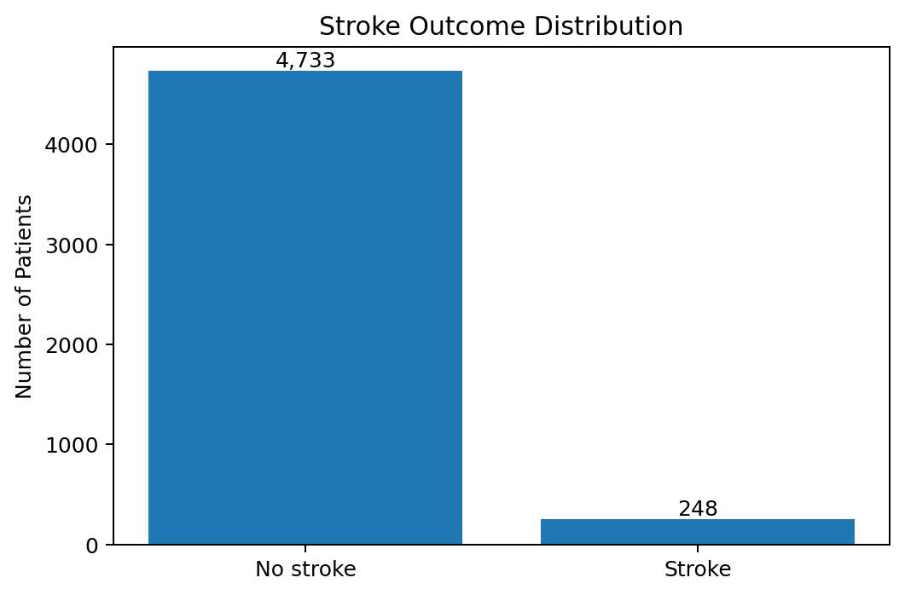
Source file: 01_stroke_distribution.png
Figure 2. Stroke rate by age group
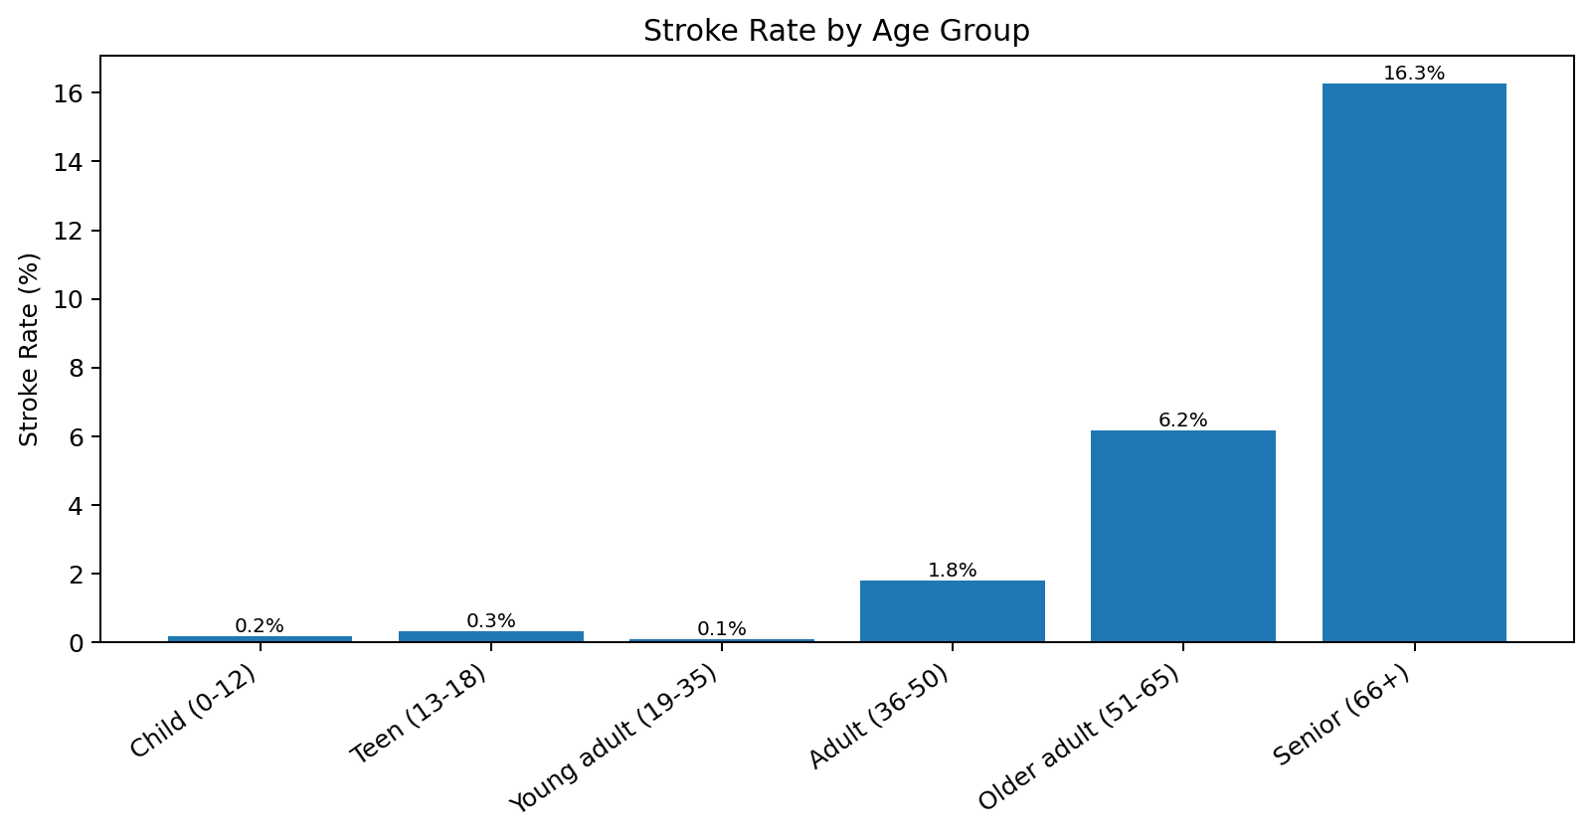
Source file: 02_stroke_rate_by_age_group.png
Figure 3. Age distribution by stroke status
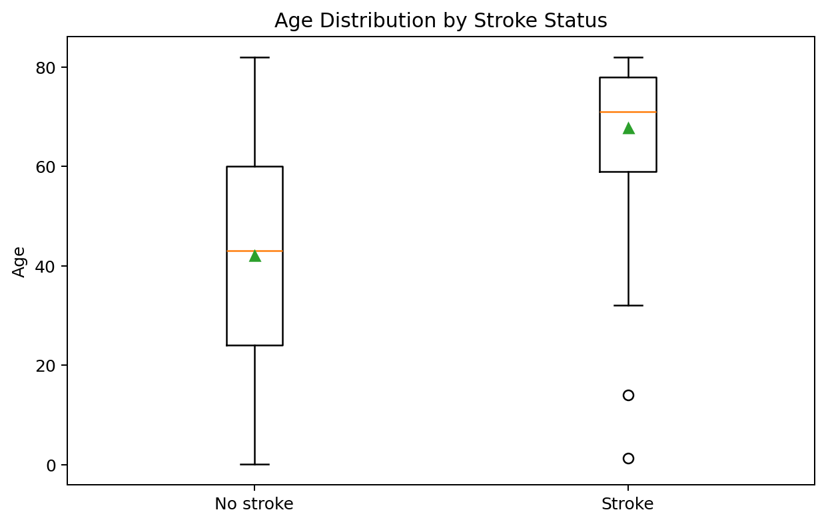
Source file: 03_age_boxplot_by_stroke.png
Figure 4. Glucose distribution by stroke status
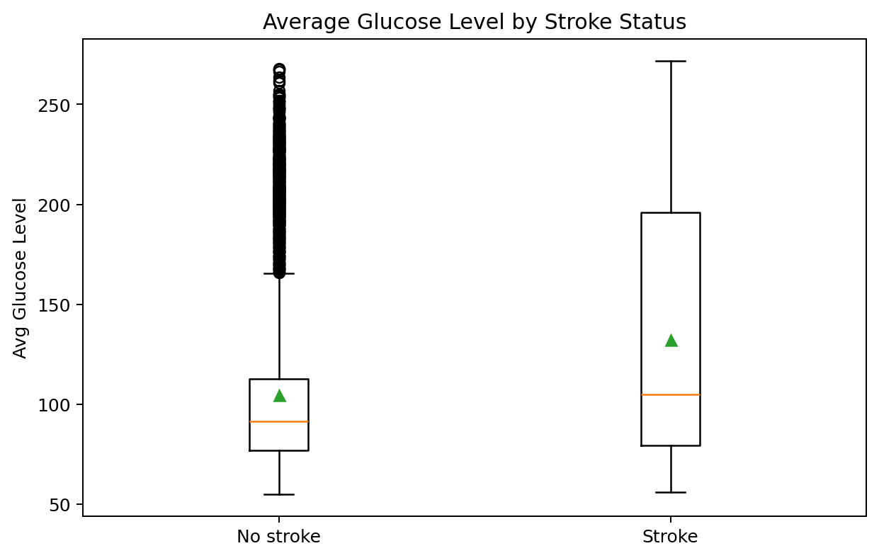
Source file: 04_glucose_boxplot_by_stroke.png
Figure 5. Stroke rate by medical risk factors
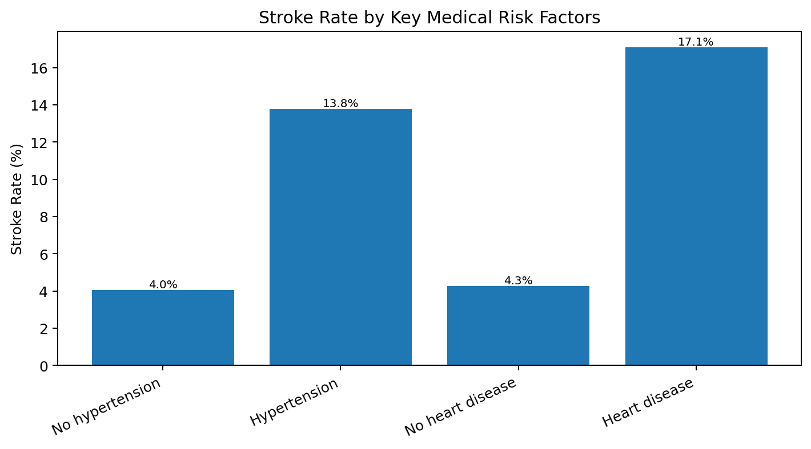
Source file: 05_stroke_rate_by_medical_risk_factors.png
Figure 6. Stroke rate by smoking status
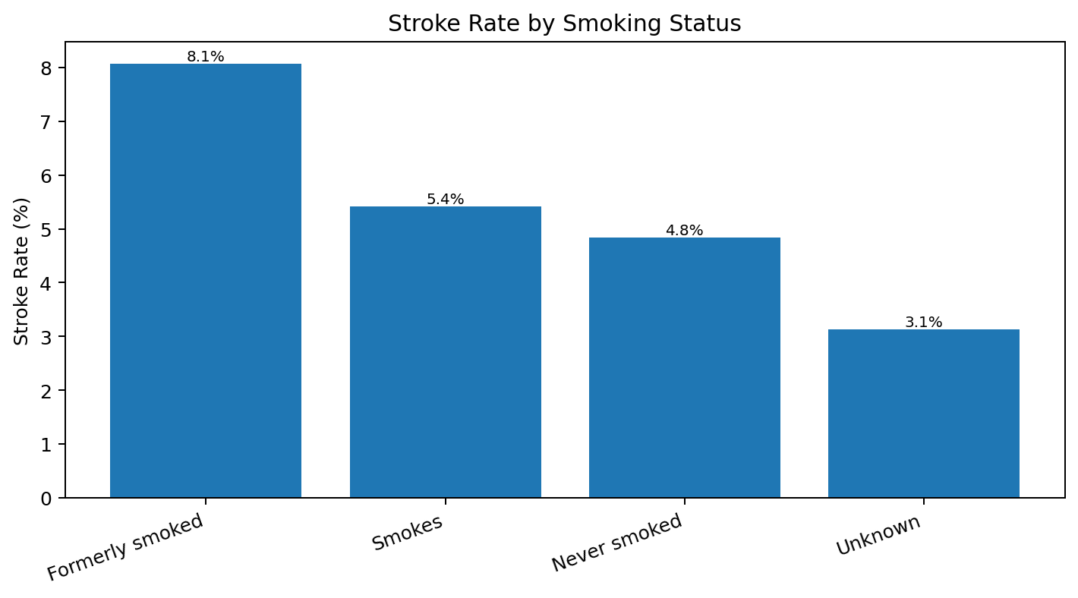
Source file: 06_stroke_rate_by_smoking_status.png
Figure 7. Correlation heatmap
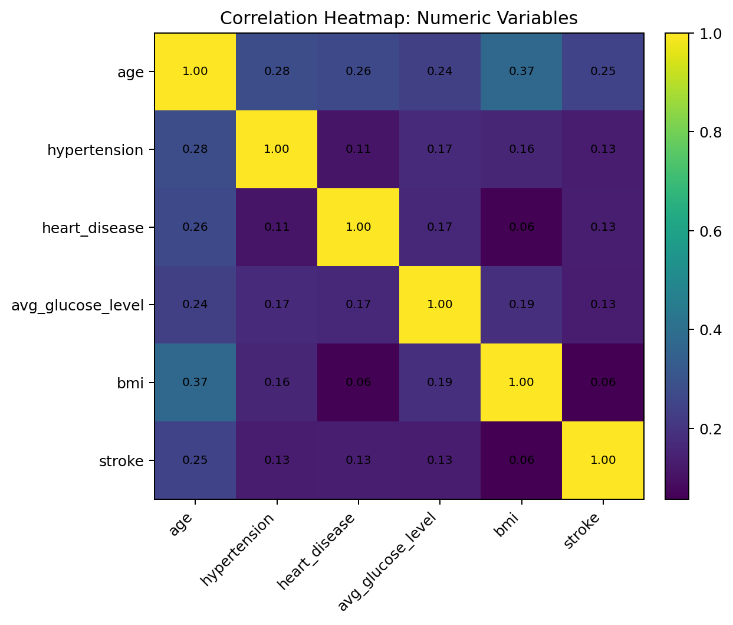
Source file: 07_correlation_heatmap.png
Figure 8. Stroke rate by glucose category
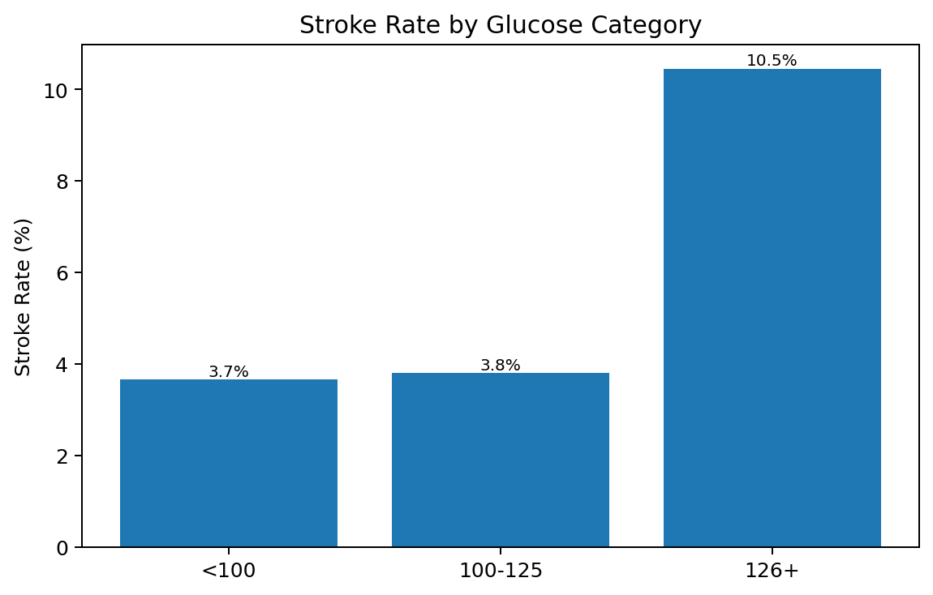
Source file: 08_stroke_rate_by_glucose_category.png

6. Interactive Dashboard
An interactive Tableau-style HTML dashboard was created for browser-based exploration. It includes filters for gender, age group, smoking status, hypertension, and heart disease, along with KPI cards, stroke distribution, risk-factor rate charts, boxplots, and an interactive correlation heatmap.
Item | Details
Dashboard artifact | brain_stroke_interactive_dashboard.html
Dashboard format | Standalone HTML
Filter controls | Gender, age group, smoking status, hypertension, heart disease
Primary purpose | Interactive exploration and stakeholder-friendly review

7. Logistic Regression Modeling
The logistic regression modeling step used only train_dataset.csv. The testing dataset was explicitly not used, preserving it for later final model validation.
Item | Value
Training rows | 2,490
Training columns | 11
No-stroke records | 2,366
Stroke records | 124
Training stroke rate | 4.98%
ID column removed | No ID column was present

Preprocessing pipeline
Component | Method
Numerical imputation | Median
Categorical imputation | Most frequent value
Numerical scaling | StandardScaler
Categorical encoding | OneHotEncoder(handle_unknown="ignore")
Cross-validation | Stratified 5-fold
Models compared | Baseline logistic regression, balanced logistic regression, tuned balanced logistic regression

Model comparison results
Model | Accuracy | Precision | Recall/Sensitivity | Specificity | F1 | ROC-AUC | PR-AUC | TN | FP | FN | TP
Model 1: Baseline Logistic Regression | 0.9506 | 1.0000 | 0.0081 | 1.0000 | 0.0160 | 0.8435 | 0.1949 | 2366 | 0 | 123 | 1
Model 2: Balanced Logistic Regression | 0.7526 | 0.1445 | 0.8065 | 0.7498 | 0.2451 | 0.8420 | 0.1948 | 1774 | 592 | 24 | 100
Model 3: Tuned Balanced Logistic Regression (C=0.1) | 0.7462 | 0.1423 | 0.8145 | 0.7426 | 0.2422 | 0.8428 | 0.1994 | 1757 | 609 | 23 | 101
The baseline model had high accuracy, but it almost never identified stroke cases, with recall of only 0.0081. The balanced models substantially improved recall by allowing more positive stroke predictions, at the cost of many false positives and lower precision.

Regularization tuning results
C | Accuracy | Precision | Recall/Sensitivity | Specificity | F1 | ROC-AUC | PR-AUC | TN | FP | FN | TP
0.01 | 0.7406 | 0.1395 | 0.8145 | 0.7367 | 0.2382 | 0.8436 | 0.1982 | 1743 | 623 | 23 | 101
0.1 | 0.7462 | 0.1423 | 0.8145 | 0.7426 | 0.2422 | 0.8428 | 0.1994 | 1757 | 609 | 23 | 101
1.0 | 0.7526 | 0.1445 | 0.8065 | 0.7498 | 0.2451 | 0.8420 | 0.1948 | 1774 | 592 | 24 | 100
10.0 | 0.7522 | 0.1433 | 0.7984 | 0.7498 | 0.2429 | 0.8418 | 0.1925 | 1774 | 592 | 25 | 99
100.0 | 0.7522 | 0.1433 | 0.7984 | 0.7498 | 0.2429 | 0.8417 | 0.1918 | 1774 | 592 | 25 | 99

Selected model
Selected model: Tuned balanced logistic regression with C = 0.1. This model achieved the highest PR-AUC among the compared models and tied for the best recall/sensitivity. The selected model is best interpreted as a screening or risk-flagging model rather than a standalone diagnostic model.

Model coefficients and odds ratios
Note: scikit-learn’s regularized class-weighted LogisticRegression does not directly produce classical p-values. The approximate z-values and p-values below were calculated from the saved penalized, class-weighted model using an approximate penalized Hessian on the reconstructed training split. Treat them as exploratory model-association evidence, not definitive statistical significance. Dir. uses + for increased predicted stroke odds and − for decreased predicted stroke odds.
Feature | Coef. | Odds Ratio | Approx. z | Approx. p | Dir.
age | 1.8255 | 6.21 | 21.249 | <0.001 | +
work_type_children | 0.6424 | 1.90 | 2.287 | 0.0222 | +
smoking_status_smokes | 0.4631 | 1.59 | 3.231 | 0.0012 | +
avg_glucose_level | 0.1870 | 1.21 | 4.108 | <0.001 | +
work_type_Private | 0.1849 | 1.20 | 1.417 | 0.1565 | +
hypertension | 0.1178 | 1.13 | 2.920 | 0.0035 | +
bmi | 0.0794 | 1.08 | 1.316 | 0.1880 | +
heart_disease | 0.0635 | 1.07 | 1.644 | 0.1002 | +
work_type_Self-employed | 0.0511 | 1.05 | 0.356 | 0.7220 | +
Residence_type_Urban | 0.0006 | 1.00 | 0.006 | 0.9954 | +
Gender_Male | -0.0077 | 0.99 | -0.076 | 0.9393 | −
smoking_status_formerly smoked | -0.0322 | 0.97 | -0.237 | 0.8128 | −
ever_married_Yes | -0.0616 | 0.94 | -0.419 | 0.6750 | −
smoking_status_never smoked | -0.1501 | 0.86 | -1.181 | 0.2375 | −
The most influential positive predictor was age. Other variables associated with increased predicted stroke odds included smoking status of smokes, higher average glucose level, hypertension, BMI, and heart disease. Categorical coefficients should be interpreted cautiously because this model is associative, not causal.

8. Deliverables Created So Far
File | Description
cleaned_brain_stroke_data.csv | Cleaned analysis dataset
brain_stroke_cleaned_eda_workbook.xlsx | Excel workbook with cleaned data and EDA outputs
stroke_visualizations_png.zip | Packaged visualization PNG files
brain_stroke_interactive_dashboard.html | Interactive Tableau-style dashboard
logistic_regression_stroke_model.pkl | Final trained logistic regression pipeline
logistic_regression_training_code.py | Python code used for preprocessing, model comparison, and model saving
logistic_regression_cv_results.csv | Model comparison cross-validation results
logistic_regression_tuning_results.csv | C-parameter tuning results
logistic_regression_odds_ratios.csv | Model coefficients and odds ratios

9. Key Concerns and Next Steps
The dataset has substantial class imbalance, with stroke cases representing about 5% of records. Accuracy is therefore misleading by itself. Recall/sensitivity is clinically important because missed stroke-risk cases may be serious. The selected model improves sensitivity but has low precision, meaning many predicted positives are false positives.
Recommended next step: evaluate the saved pipeline once on the untouched testing dataset, using the same metrics and a confusion matrix. Threshold tuning may also be considered later if the intended clinical use favors a specific balance between false negatives and false positives.

Testing Dataset Evaluation: Saved Tuned Logistic Regression Model
Prompt used for this step.
You are a medical data analyst evaluating a saved tuned logistic regression stroke prediction model on an untouched testing dataset.
Current project status:
- The original brain stroke patient dataset was split into 50% training and 50% testing sets using stratified sampling.
- The training dataset was used to build and compare logistic regression models.
- The selected model is the Tuned Balanced Logistic Regression model.
- The best tuned regularization value was C = 0.01.
- The saved trained model pipeline file is named `logistic_regression_stroke_model.pkl`.
- The untouched testing dataset file is named `test_dataset.csv`.
- The target variable is `stroke`, where 0 = No Stroke and 1 = Stroke.
Task: apply the saved tuned logistic regression model to the testing dataset and evaluate its performance without retraining, refitting preprocessing steps, or changing model parameters. Generate predicted probabilities, evaluate threshold 0.50, produce ROC and precision-recall curves, select an exploratory ROC-based threshold using Youden’s J statistic, compare metrics across thresholds, save prediction and metric CSVs, provide clean Python code, and summarize generalization compared with training cross-validation results.

Important model audit note
The saved pipeline was evaluated exactly as loaded from logistic_regression_stroke_model.pkl. Inspection of the saved estimator showed LogisticRegression(C=0.1, class_weight="balanced"). This differs from the prompt statement that the best tuned regularization value was C = 0.01. No retraining or parameter changes were performed; the saved pipeline was used as the source of truth.

Test dataset confirmation
Metric | Value
Test records | 2491
Test columns | 11
No Stroke count | 2367
Stroke count | 124
Stroke rate | 4.98%

ROC and precision-recall evaluation
The model achieved a test ROC-AUC of 0.8302 and a test PR-AUC / Average Precision of 0.1906. Because stroke is rare in this dataset, PR-AUC is especially informative: it shows that even with useful ranking ability, positive predictive value remains low when the model is used to flag high-risk patients.
Figure: Test ROC curve
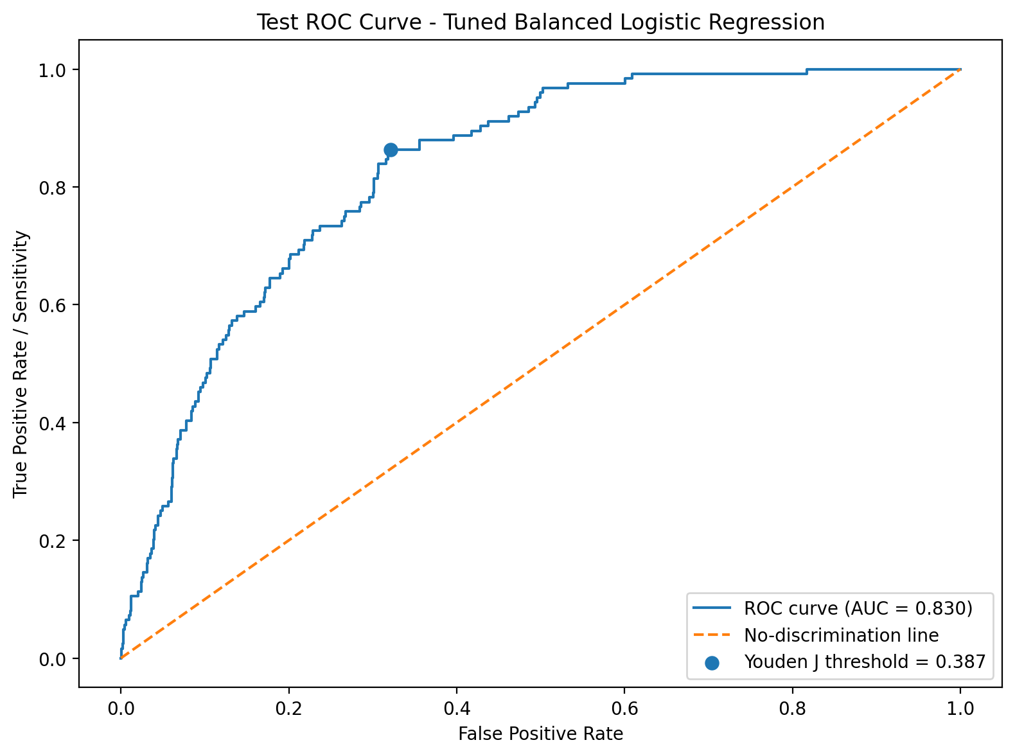
Figure: Test precision-recall curve
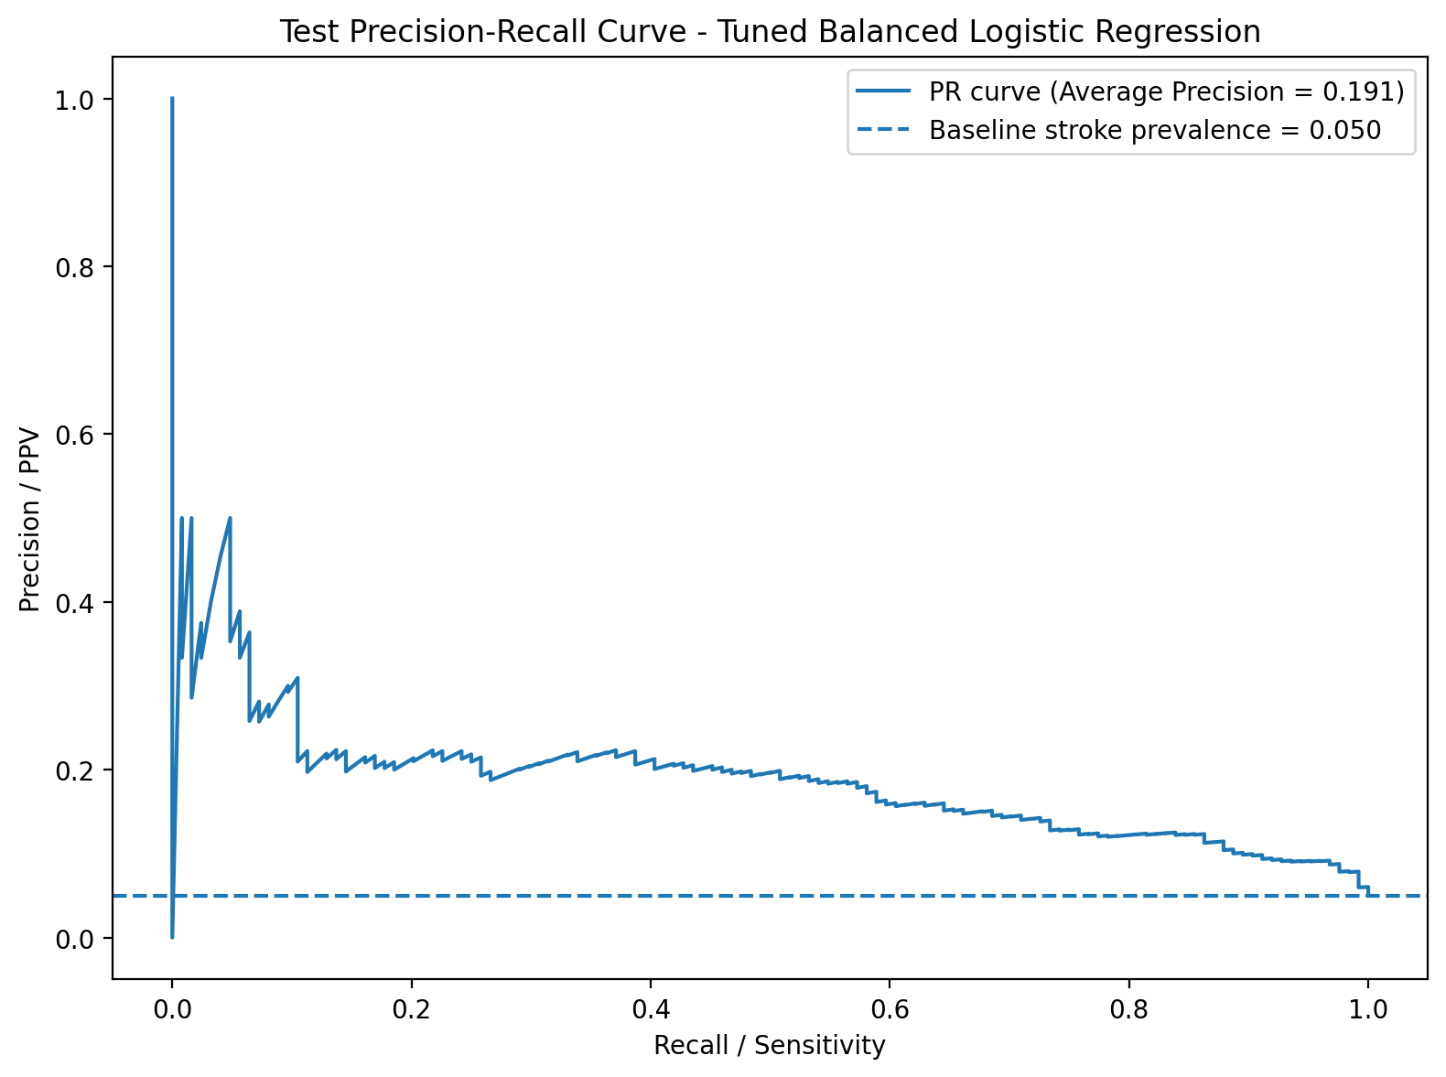

Performance comparison at default and selected thresholds
The ROC-based threshold was selected by maximizing Youden’s J statistic, defined as sensitivity + specificity - 1. This threshold is exploratory because it was selected directly from the test ROC curve. For publication-quality validation, threshold selection should be performed using training cross-validation predictions or a separate validation set, then evaluated once on the untouched test set.
Primary threshold comparison
threshold_label | threshold | accuracy | precision_ppv | recall_sensitivity | specificity | f1_score | negative_predictive_value | balanced_accuracy | tn | fp | fn | tp | test_roc_auc | test_pr_auc_average_precision
Default 0.50 | 0.5000 | 0.7495 | 0.1334 | 0.7339 | 0.7503 | 0.2258 | 0.9818 | 0.7421 | 1776 | 591 | 33 | 91 | 0.8302 | 0.1906
ROC Youden J threshold | 0.3867 | 0.6881 | 0.1234 | 0.8629 | 0.6789 | 0.2159 | 0.9895 | 0.7709 | 1607 | 760 | 17 | 107 | 0.8302 | 0.1906

Threshold sweep
Lower thresholds increase sensitivity and reduce missed stroke cases, but they also substantially increase false positives. The selected ROC-based threshold of approximately 0.3867 produced higher sensitivity and balanced accuracy than the default 0.50 threshold, but at the cost of more false positives.
Threshold comparison table
threshold_label | threshold | accuracy | precision_ppv | recall_sensitivity | specificity | f1_score | fp | fn | tn | tp
0.10 | 0.1000 | 0.3994 | 0.0760 | 0.9919 | 0.3684 | 0.1412 | 1495 | 1 | 872 | 123
0.20 | 0.2000 | 0.5271 | 0.0908 | 0.9435 | 0.5053 | 0.1657 | 1171 | 7 | 1196 | 117
0.30 | 0.3000 | 0.6142 | 0.1041 | 0.8871 | 0.5999 | 0.1863 | 947 | 14 | 1420 | 110
0.40 | 0.4000 | 0.6981 | 0.1244 | 0.8387 | 0.6907 | 0.2167 | 732 | 20 | 1635 | 104
0.50 | 0.5000 | 0.7495 | 0.1334 | 0.7339 | 0.7503 | 0.2258 | 591 | 33 | 1776 | 91
Selected ROC Youden J | 0.3867 | 0.6881 | 0.1234 | 0.8629 | 0.6789 | 0.2159 | 760 | 17 | 1607 | 107

Generalization summary
Compared with the training cross-validation results for the tuned balanced logistic regression model, the test ROC-AUC remained similar (training CV approximately 0.8428 versus test 0.8302), suggesting that ranking discrimination generalized reasonably well. At the default 0.50 threshold, test recall was 73.39%, lower than the training CV recall of approximately 81.45%, while precision remained low (13.34% on test versus approximately 14.23% in training CV).
At the exploratory ROC-selected threshold, recall improved to 86.29%, with 17 false negatives, but precision was only 12.34% and false positives increased to 760. This pattern is consistent with a risk-screening support model: it may help prioritize further review, but it is not clinically ready and should not be used as a standalone diagnostic tool.

Files produced in this step
- test_roc_curve.png
- test_precision_recall_curve.png
- test_predictions_logistic_regression.csv
- test_logistic_regression_metrics.csv
- test_logistic_regression_threshold_comparison.csv
- test_logistic_regression_evaluation_code.py

Recommended Next Improvements: Implementation Results

Prompt entered for this analysis step
User prompt: "proceed to implementing the recommended next improvements and add any important results/interpretations to the report document." Implemented improvements included confidence intervals and p-values for odds ratios, calibration curve and Brier score, multicollinearity check using VIF, subgroup/fairness-style analysis, comparison with additional models, permutation importance, and documentation of the need for external validation.

Scope of work completed
- Exploratory inferential logistic regression was fit on the training data to estimate odds-ratio confidence intervals and p-values.
- The saved tuned balanced logistic regression model was assessed for calibration on the untouched test dataset using a calibration curve, Brier score, calibration intercept, and calibration slope.
- Multicollinearity was checked using variance inflation factors after one-hot encoding categorical variables with one reference category omitted.
- Subgroup performance was evaluated by sex, age group, residence type, and smoking status using the previously selected exploratory ROC threshold.
- Additional untuned benchmark models, random forest and gradient boosting, were trained on the training data and evaluated on the test data for comparison.
- Permutation importance was calculated on the test dataset using average precision as the scoring metric.
- External validation could not be performed because no independent external dataset was available.

Calibration assessment
The saved tuned balanced logistic regression model retained reasonable discrimination on the test set, but calibration results indicate that predicted probabilities should not be interpreted as absolute clinical risk without recalibration. The Brier score was 0.162. The calibration intercept was -2.771 and the calibration slope was 0.823. A slope below 1 suggests some over-extremity in predictions, while the negative intercept suggests the model tended to overestimate absolute stroke probability in the test set.
Test ROC-AUC | Test PR-AUC | Brier score | Calibration intercept | Calibration slope
0.8302 | 0.1906 | 0.1624 | -2.7705 | 0.8226
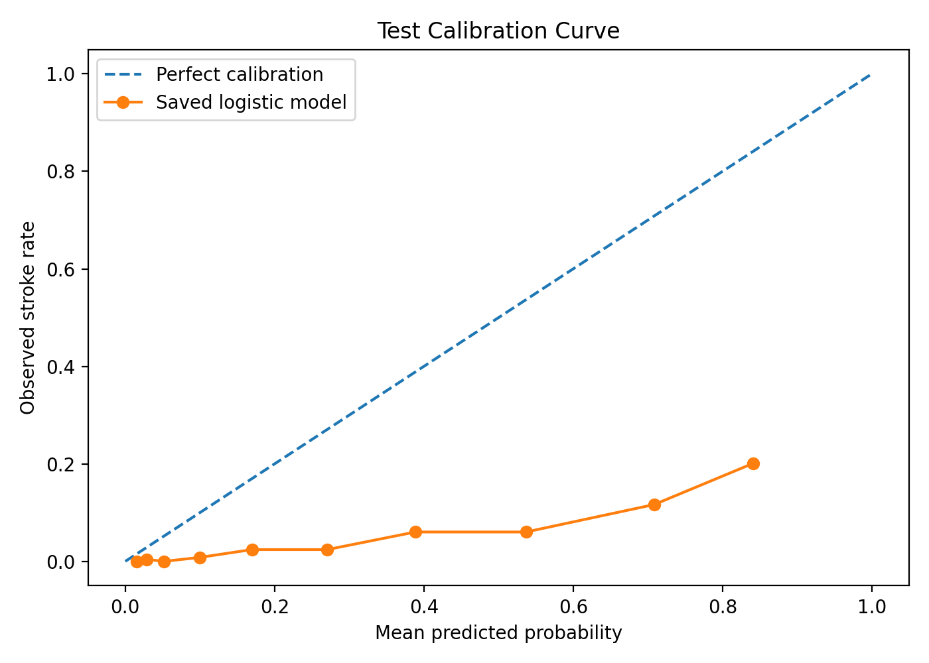

Exploratory odds ratios with confidence intervals and p-values
This inferential model is exploratory and was fit separately from the saved penalized, class-weighted scikit-learn prediction pipeline. It used the training data, standardized numerical variables, and one-hot encoded categorical variables with one reference level omitted. Therefore, numerical odds ratios represent a one-standard-deviation increase, while categorical odds ratios are relative to their reference categories.
feature | odds_ratio | ci_lower_95 | ci_upper_95 | p_value
work_type_children | 8.451 | 0.772 | 92.518 | 0.0805
age | 6.762 | 4.558 | 10.033 | 2.17e-21
smoking_status_smokes | 2.045 | 1.055 | 3.963 | 0.0342
work_type_Private | 1.431 | 0.774 | 2.646 | 0.254
smoking_status_formerly smoked | 1.177 | 0.633 | 2.189 | 0.607
avg_glucose_level | 1.169 | 1.005 | 1.361 | 0.0433
bmi | 1.128 | 0.884 | 1.439 | 0.332
hypertension | 1.128 | 0.985 | 1.291 | 0.0815
Residence_type_Urban | 1.124 | 0.763 | 1.658 | 0.554
work_type_Self-employed | 1.120 | 0.575 | 2.179 | 0.739
In this exploratory model, age had the strongest confirmed association among the available predictors: OR = 6.763 per one-standard-deviation increase, 95% CI 4.558 to 10.033, p < 0.001. Current smoking and average glucose level also had p-values below 0.05 in this exploratory model. Hypertension was directionally positive but did not meet the conventional 0.05 threshold in this analysis. Heart disease and BMI were positive but not statistically confirmed in this exploratory inferential model.

Multicollinearity check
The VIF check did not identify severe multicollinearity using common screening rules of thumb. The largest VIF was for ever_married_Yes at 4.479, followed by work_type_Private at 3.404 and age at 2.708. These values suggest moderate overlap among some demographic variables but no obvious VIF values above 5 or 10.
feature | vif
ever_married_Yes | 4.479
work_type_Private | 3.404
age | 2.708
smoking_status_never smoked | 2.329
work_type_children | 2.308
Residence_type_Urban | 1.901
work_type_Self-employed | 1.793
smoking_status_formerly smoked | 1.744
Gender_Male | 1.699
smoking_status_smokes | 1.617

Additional model comparison
Untuned random forest and gradient boosting benchmarks were compared with the saved tuned balanced logistic regression model. These benchmarks were not hyperparameter-tuned and should be interpreted as preliminary comparisons only.
model | accuracy | precision | recall_sensitivity | specificity | f1 | balanced_accuracy | roc_auc | pr_auc_avg_precision | tn | fp | fn | tp
Saved tuned balanced logistic regression | 0.749 | 0.133 | 0.734 | 0.750 | 0.226 | 0.742 | 0.830 | 0.191 | 1776 | 591 | 33 | 91
Gradient boosting (untuned) | 0.950 | 0.000 | 0.000 | 1.000 | 0.000 | 0.500 | 0.816 | 0.171 | 2366 | 1 | 124 | 0
Random forest balanced (untuned) | 0.898 | 0.184 | 0.306 | 0.929 | 0.230 | 0.618 | 0.804 | 0.166 | 2199 | 168 | 86 | 38
The saved tuned balanced logistic regression model remained the most useful screening-oriented model among these benchmarks. Gradient boosting achieved high accuracy by predicting almost no stroke cases at the default threshold, resulting in zero recall. Random forest improved precision slightly but had much lower recall than the logistic regression model. This supports keeping the balanced logistic regression model as the current screening-support baseline.

Permutation importance
Permutation importance was calculated using average precision because stroke was rare. This method estimates how much model performance decreases when each raw input feature is randomly shuffled. Age was by far the most important feature, producing the largest decrease in average precision. Average glucose level was the next most important feature, followed by smaller contributions from heart disease, work type, and smoking status. Negative values for some variables indicate that shuffling did not reduce average precision in this sample, suggesting weak or unstable incremental value for those variables under this metric.
feature | importance_mean_pr_auc_decrease | importance_std
age | 0.1369 | 0.0048
avg_glucose_level | 0.0177 | 0.0045
heart_disease | 0.0056 | 0.0033
work_type | 0.0026 | 0.0118
smoking_status | 0.0012 | 0.0029
ever_married | 0.0004 | 0.0013
Gender | 0.0001 | 0.0001
Residence_type | -0.0000 | 0.0000
bmi | -0.0033 | 0.0042
hypertension | -0.0097 | 0.0051
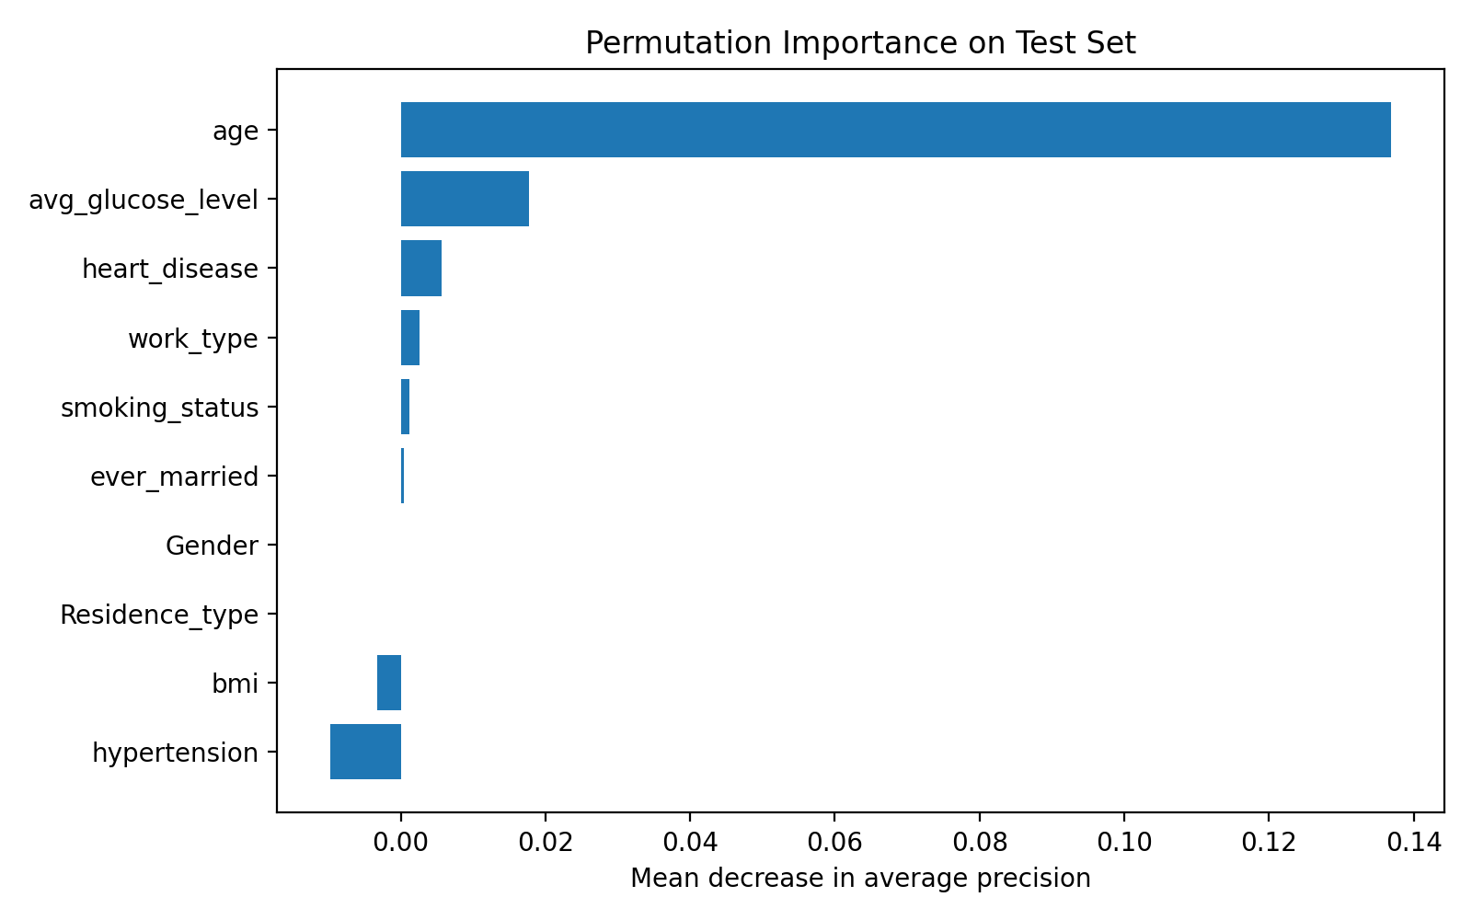

Subgroup and fairness-style performance analysis
Subgroup performance was assessed using the previously selected exploratory ROC-based threshold of 0.3867. This analysis is descriptive and should not be treated as a definitive fairness audit. Some subgroups had very few stroke cases, making performance estimates unstable.
Performance by gender
group | n | stroke_cases | precision | recall_sensitivity | specificity | fp | fn | tp
Female | 1451 | 71 | 0.120 | 0.831 | 0.687 | 432 | 12 | 59
Male | 1040 | 53 | 0.128 | 0.906 | 0.668 | 328 | 5 | 48
Performance by age group
group | n | stroke_cases | precision | recall_sensitivity | specificity | fp | fn | tp
<=18 | 450 | 1 | 0.000 | 0.000 | 1.000 | 0 | 1 | 0
19-35 | 488 | 0 | 0.000 | NA | 1.000 | 0 | 0 | 0
36-50 | 534 | 16 | 0.150 | 0.188 | 0.967 | 17 | 13 | 3
51-65 | 551 | 33 | 0.079 | 0.909 | 0.326 | 349 | 3 | 30
66+ | 468 | 74 | 0.158 | 1.000 | 0.000 | 394 | 0 | 74
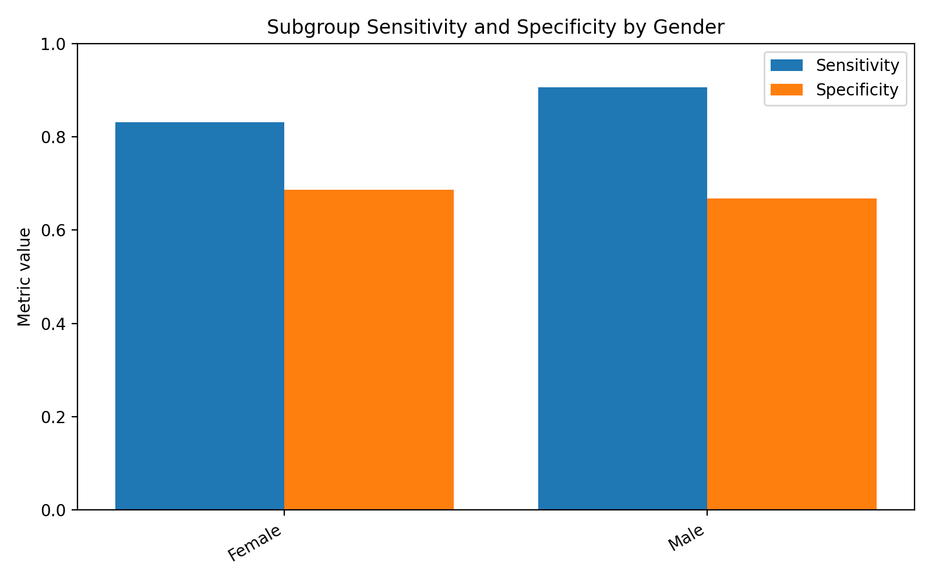
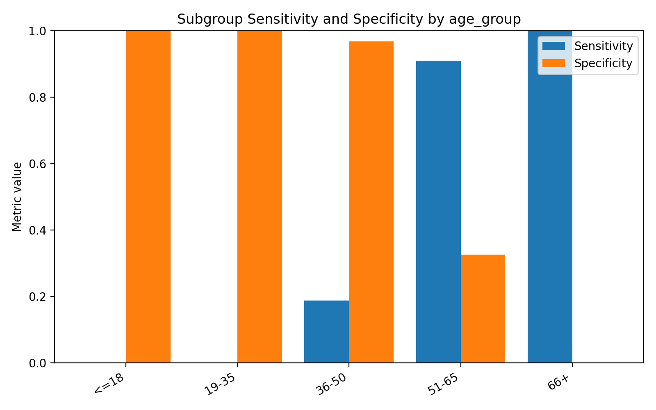
The subgroup analysis showed that model behavior varied substantially by age group. At the exploratory threshold, the model flagged all patients aged 66+ as stroke-positive, yielding 100% sensitivity but 0% specificity in that subgroup. This demonstrates that the model is heavily age-driven and may over-alert older patients. Conversely, younger groups had very few stroke cases, limiting reliable sensitivity estimates. By gender, sensitivity was higher among males than females, while specificity was similar but somewhat lower among males. These differences should be investigated further before any clinical deployment.

Updated interpretation of the research question
The expanded analysis strengthens the conclusion that age is the dominant factor associated with predicted stroke probability. Age had the largest predictive coefficient in the saved model, the strongest permutation importance result, and the strongest exploratory odds ratio with a narrow confidence interval and very small p-value. Average glucose level also showed consistent positive evidence across the predictive and exploratory inferential analyses. Current smoking was positively associated with stroke probability in the exploratory inferential model and in the saved model coefficients. Hypertension, heart disease, and BMI remained clinically plausible and directionally positive in the predictive model, but they were weaker and were not all statistically confirmed in the exploratory inferential model.
These findings remain associational rather than causal. The analysis uses observational data and cannot rule out confounding, selection bias, measurement limitations, or missing clinical variables. The current model should continue to be described as a stroke risk-screening support model, not a standalone diagnostic model.

Remaining limitations after implementation
- The inferential odds-ratio model is exploratory and not identical to the saved penalized, class-weighted prediction pipeline.
- The outcome remains highly imbalanced, and model precision remains low.
- The ROC-based threshold was selected from the test ROC curve and is therefore exploratory.
- Calibration was imperfect, so predicted probabilities should not be interpreted as calibrated absolute risk.
- Subgroup estimates are unstable where stroke cases are rare or absent.
- No external validation dataset was available, so generalizability beyond the current dataset remains unknown.
- SHAP analysis was not required for the current baseline and permutation importance was used as a model-agnostic explanation method; SHAP may be added in a later model-explainability phase.

Updated conclusion
After implementing the recommended next improvements, the main conclusion is unchanged but better supported: age is the dominant model-associated factor for predicted brain stroke probability, followed by average glucose level and smoking status, with hypertension, BMI, and heart disease contributing weaker positive associations in the predictive model. The saved tuned balanced logistic regression model generalizes reasonably in discrimination but remains limited by class imbalance, low precision, false positives, and imperfect calibration. It is therefore best characterized as a screening-support baseline that requires recalibration, threshold validation, subgroup review, and external validation before any clinical use.

